**Network**: A Network is a collection of interconnected devices, such as computers, printers, and servers, that can communicate with each other.

**Terminologies in Network:**

1. **Client:**

A host can act as a **Client** when he is requesting information.

1. **Server:**

A host can act as a **Server** when he provides information.

1. **Peer:**

A host can also request and provide information, which is called **Peer**.

1. **Node:**

Any device connected to a network, such as a computer, printer, or router.

1. **Protocol:**

A set of rules and standards that define how devices on a network communicate with each other.

1. **IP Address:**

A unique numerical identifier assigned to each device on a network, used to identify and communicate with other devices.

1. **Router:**

A networking device that connects multiple networks together and forwards data packets between them.

1. **Switch:**

A networking device that connects devices on a network and forwards data packets between them.

1. **Firewall:**

A security device or software that monitors and controls incoming and outgoing network traffic, based on a set of predefined security rules.

1. **DNS (Domain Name System):**

A system that translates domain names (such as www.example.com) into IP addresses, allowing devices to locate and connect to websites and other network resources.

1. **Some Types of Network:**
   1. **LAN** (Local Area Network): A network that connects devices within a limited geographical area, such as a home, office, or building.
   2. **MANs** (Metropolitan Area Networks)
   3. **WAN** (Wide Area Network): A network that connects devices over a large geographical area, such as multiple offices in different cities or countries.
   4. **SAN** (Storage Area Network): A SAN provides systems with high-speed, lossless access to high-capacity storage devices.
   5. **VPN** (Virtual Private Network): A VPN allows for information to be securely sent across a public or unsecured network, such as the Internet. Common uses of a VPN are to connect branch offices or remote users to the main office.
2. **Some basic Protocols are:**

* **IP**: Internet Protocol
* **FTP**: File Transfer Protocol
* **SMTP**: Simple Mail Transfer Protocol
* **HTTP**: Hyper Text Transfer Protocol
* **DHCP** **(Dynamic Host Configuration Protocol):** A protocol that automatically assigns IP addresses and network configuration settings to devices on a network.

1. **Network reference models:**

Network reference models were developed to allow products from different manufacturers to interoperate on a network. A network reference model serves as a blueprint, detailing standards for how protocol communication should occur. The most widely recognized reference models are the:

* 1. Open Systems Interconnect (OSI) Model
  2. TCP/IP (Transmission Control Protocol/Internet Protocol): A set of protocols used to communicate over the internet and other networks.

**Open Systems Interconnect (OSI) Model**

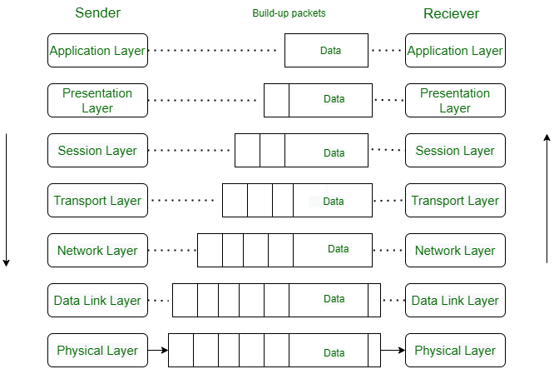 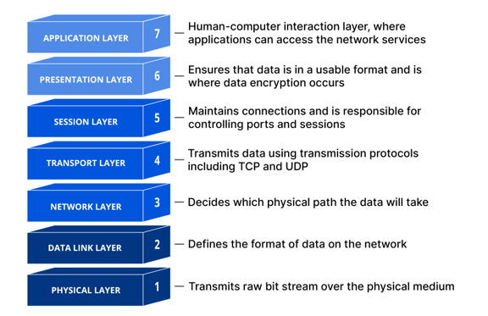

**TCP/IP (Transmission Control Protocol/Internet Protocol):**

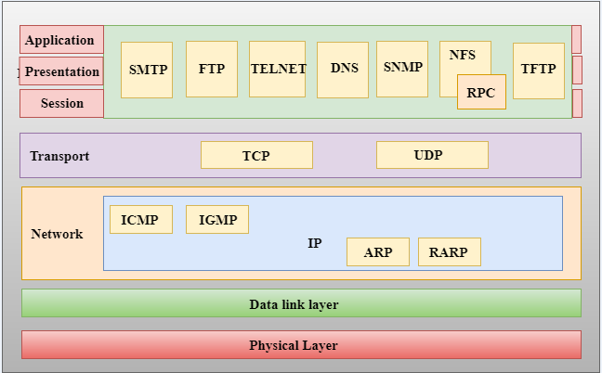

**Difference:**

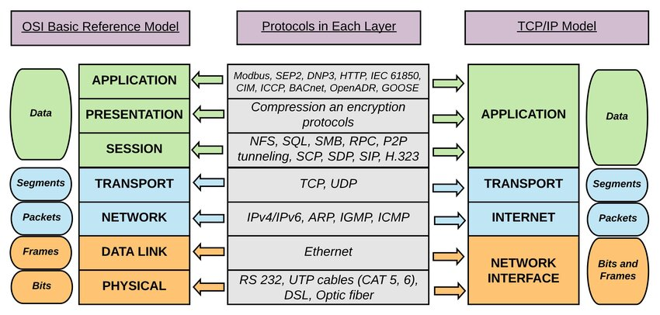

| **TCP/IP** | **OSI** |
| --- | --- |
| TCP refers to Transmission Control Protocol. | OSI refers to Open Systems Interconnection. |
| TCP/IP uses both the session and presentation layer in the application layer itself. | OSI uses different session and presentation layers. |
| TCP/IP follows connectionless a horizontal approach. | OSI follows a vertical approach. |
| The Transport layer in TCP/IP does not provide assurance delivery of packets. | In the OSI model, the transport layer provides assurance delivery of packets. |
| Protocols cannot be replaced easily in TCP/IP model. | While in the OSI model, Protocols are better covered and are easy to replace with the technology change. |
| TCP/IP model network layer only provides connectionless (IP) services. The transport layer (TCP) provides connections. | Connectionless and connection-oriented services are provided by the network layer in the OSI model. |